DOCUMENT 35 — Launch Runbook (September 1 Beta)
Visionary Internal · v1.0 · Opening the gates to 1,00,000 learners

The beta is not a marketing event; it is a stress test of the flywheel. We invite
users in cohorts to protect the L4 model routing and L7 ingest pipelines from
thundering-herd failures.

1. The Cohort Rollout
- Day -7: Load test L4 inference and L7 Kafka ingest at 2x expected peak.
- Day 0 (Sept 1): Invite Cohort 1 (10% of waitlist = 2,000 users). Focus on JEE
Physics Hindi beachhead.
- Day 3: If TTFT ≤200ms and hallucination <0.5% hold, invite Cohort 2 (40%).
- Day 7: Open to 100% of the 20,000 waitlist.
- Day 14: Open public waitlist for Phase 2 scaling.

2. War Room & Incident Response
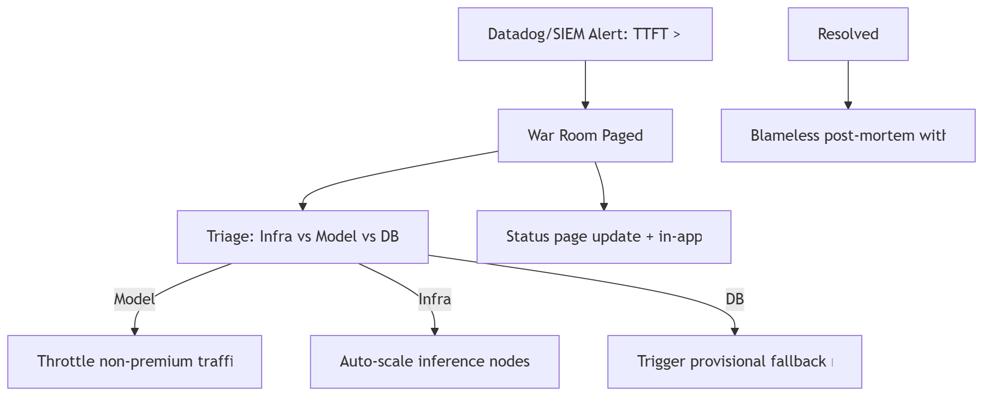

3. Success Criteria for Beta (Day 30)
- D30 Retention ≥45% (Empire Phase 1 gate).
- SCM coverage ≥80% of Phase 1 syllabus.
- L7 Flywheel has ingested ≥100,000 verified interaction events (triggering Doc 10
Phase 2 fine-tuning).
- Zero critical safety or child-protection breaches (Doc 23).

4. Rules
- If the L4 model degrades, the app falls back to deterministic SCM-driven text
explanations (no 3D, no streaming) rather than showing errors.
- In-app banners must be honest: "High traffic, answers may take 5 seconds" rather
than generic "Network error."

OKF
KF1 Cohort 1 infrastructure survives 2x load test · KF2 Day 30 retention ≥45% ·
KF3 100K L7 events logged by Day 30 · KF4 zero safety breaches · KF5 war room
response time <5 minutes for P1 alerts.

